**STARTING A DC MOTOR**

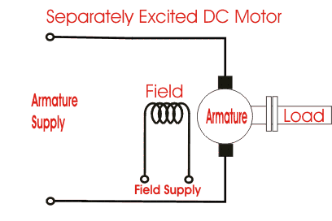

Figure 1: Simplified Model of DC Motor

DC Machines are working using DC current instead of AC current. Depending on the current flow, they can be operated as a generator or a motor. When the power is generated by external power source like battery, it operates as a motor in order to convert the electrical energy to the mechanical energy. On the other hand, when mechanical energy is used to supply an electrical energy, it acts like a generator.

DC Machines consist of two main parts which are stator and rotor. Stator is a stationary part that places at the outer part of the dc machine while rotor is a rotational part that places inner part of the machine. The working principle is based on the flux between rotor and stator. When DC Machine is used for motor action, produced magnetic field in the stator and current is carried by armature windings form a force on the armature winding that results a circular rotation of rotor. In addition, increasing the number of armature windings results to distribute the force properly because the force is proportional to the cosine between magnetic field and current direction.

DC Motors are basically classified according to excitation type. There are three types of DC Motor exist. For permanent magnet type , stator consists of a magnet that produces a constant magnetic field between its poles and the armature current is produced by an external dc source. For the self-excited type both the stator and armature current are supplied by the same power source that has an advantage to control the motor with arranging the voltage of the source. Finally, in separately excited type, which will be simulated, field and armature are supplied with different sources. In addition, it enables us to control the flux of the field independently.

**Start-Up Process**

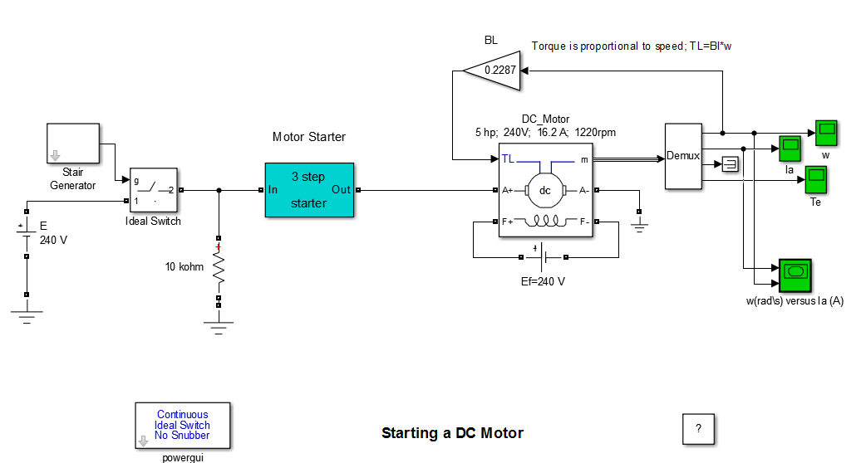

Figure 2: Schematic of Circuit

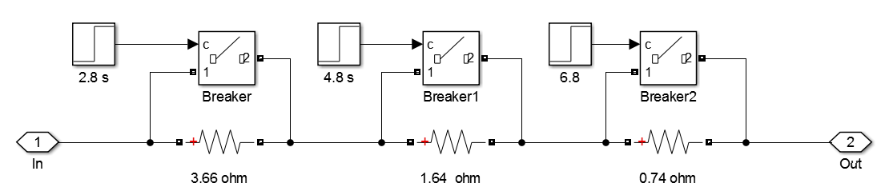

Figure 3: Schematic of Motor Starter

In the simulation of the start-up process, a constant dc source is connected to the field in order to produce a constant flux. With a constant flux of the field, electromechanical torque is proportional to the armature current and also armature voltage is proportional to the rotor speed. However, at the beginning of the start, the motor draws very high current from the source because speed is very low that causes low induced emf voltage. Furthermore, motor will be damaged because of existence of the high current value. In order to overcome the inrush current, simple and effective solution is performed.

In Figure 3, three series resistances are connected in series with the power source to limit the armature current. With the increase of the rotor speed, series added resistances will be taken out of the circuit by short circuited them using circuit breakers because increasing the speed results an increase in induced emf voltage.

**Motor Information**

Rated Voltage: 240V Armature Inductance: 0.012H Armature Resistance: 0.6ohm

Rated Current: 16.2A Field Inductance: 120H Field Resistance: 240ohm

Rated Power: 5HP Field-Armature Mutual Inductance: 1.8H

**Power Source and Control System**

Power Source is selected according to obtain the rated values.

In control system constant gain will be selected according to obtain the rated torque at rated speed.

**Equations**

Induced EMF: Eo = 240-16.2*0.6 = 230.3 V

Pe = 230.3*16.2 = 3731 W = 5.0 HP

Field current: If = 240/240 =1 A

Eo = w*Laf*If ---> w = (Eo/La*If) speed w = 230.3/1.8 = 127.7 rad/s = 1220 r/min

Nominal torque: Te = Pe/w = 3731/127.7 = 29.2 N.m

**Simulation Results**

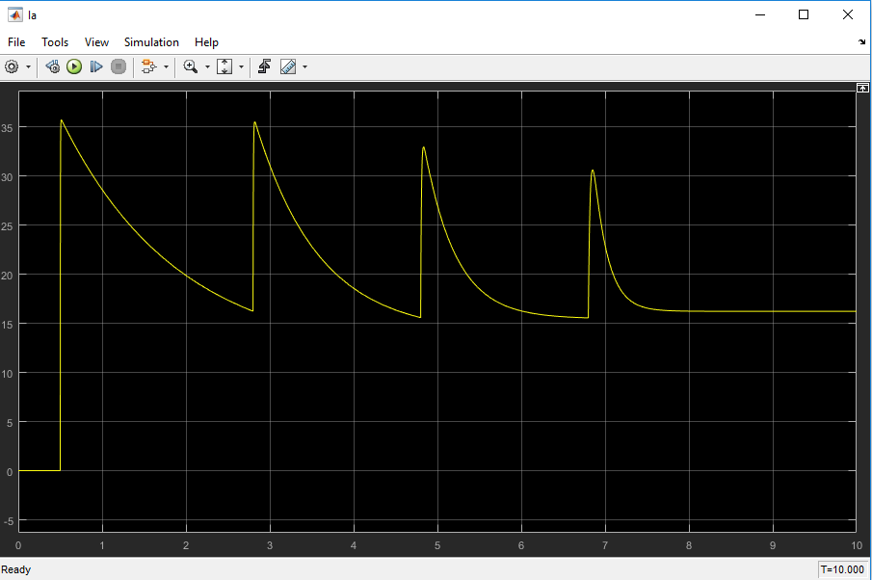

Figure 4: Armature current vs time

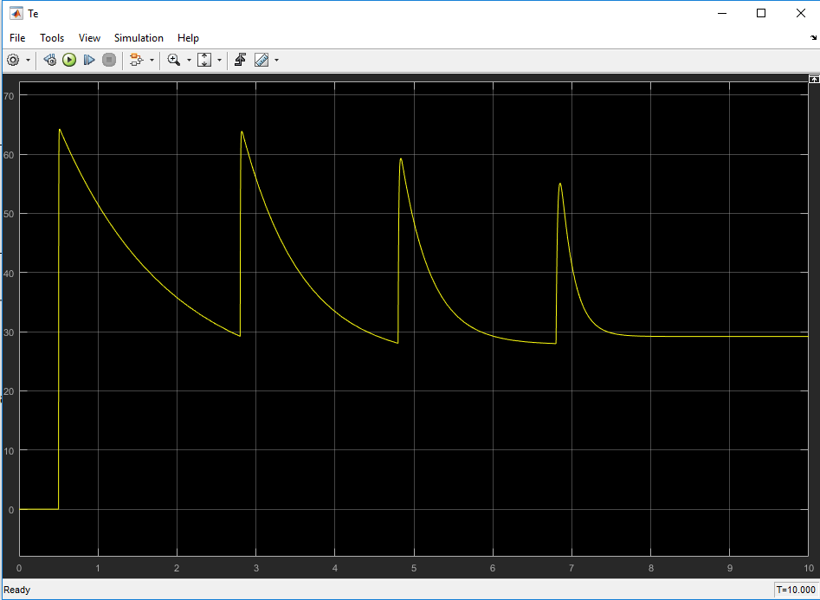

Figure 5: Torque vs time

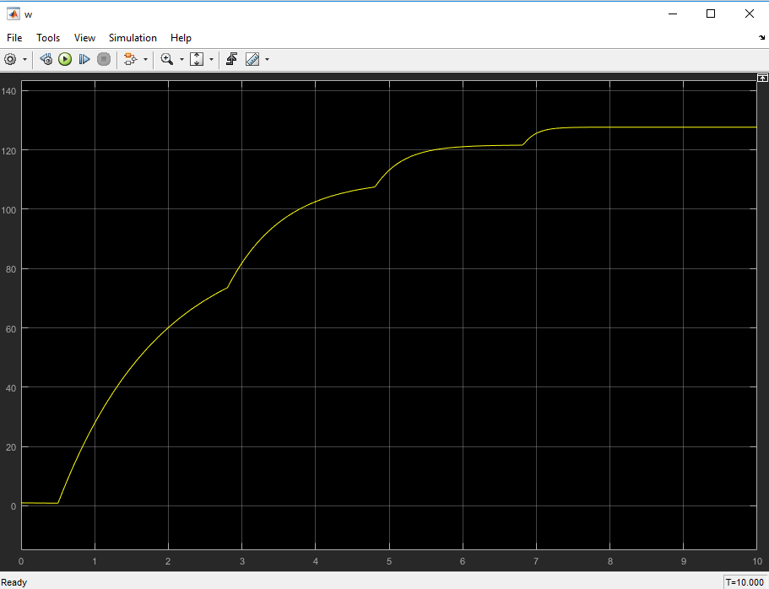

Figure 6: Angular Velocity vs time

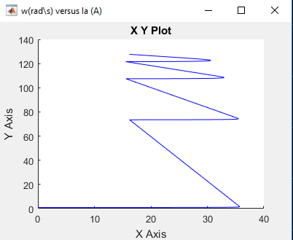

Figure 7: Angular Velocity vs Armature Current

Instantaneous rising of the armature current produces an instantaneous torque increasement because torque is directly proportional to the armature current. With higher rotational speeds drawing higher armature current becomes harder on grounds that rotational speed is directly proportional to the induced emf voltage.

**References**

https://www.mathworks.com/help/physmod/sps/examples/starting-a-dc-motor.html